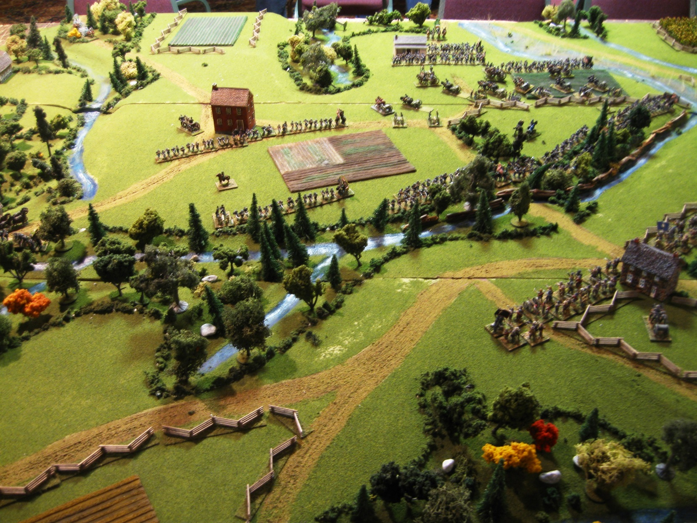

This game teach players to view some situation from other side.

In this game there are 2 part.

* In first part you should kill enemies and win war.
* In second part you are in favor of enemy. But not as soldier, you are only nurse.

|  |
| --- |
|  |

|  |
| --- |
|  |

One day king want new lands. He thinks he’s land area is too small. So, he start war vs. neighbor kingdom. Other kingdom is very weak in military.

**Who are you?**

28.06.2016

*Your territory*

*Enemy territory*